 | Government of Pakistan  Prime Minister’s Office (Public)  Earthquake Reconstruction and Rehabilitation Authority, Opposite Margalla Town, Main Murree Road, Islamabad | 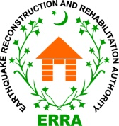
F.No. 14(25)/Gen Corres/Proc/2024
Subject: Cancellation - Auction of Old Stores and IT Equipment in AJK
Reference Advertisement dated 24th April, 2024 in PPRA & ERRA Websites and 26th April, 2024 in newspapers (DAWN, Islamabad and Daily Asas, Rawalpindi) on subject noted. “Due to prevailing law & Order situation in AJK, Auction on 16,17 and 18th May, 2024 in Muzaffarabad, Bagh and Rawalakot are cancelled. Next date will be announced through print and electronic media soon.

Mir Hamza Storyani
Director (Procurement)

